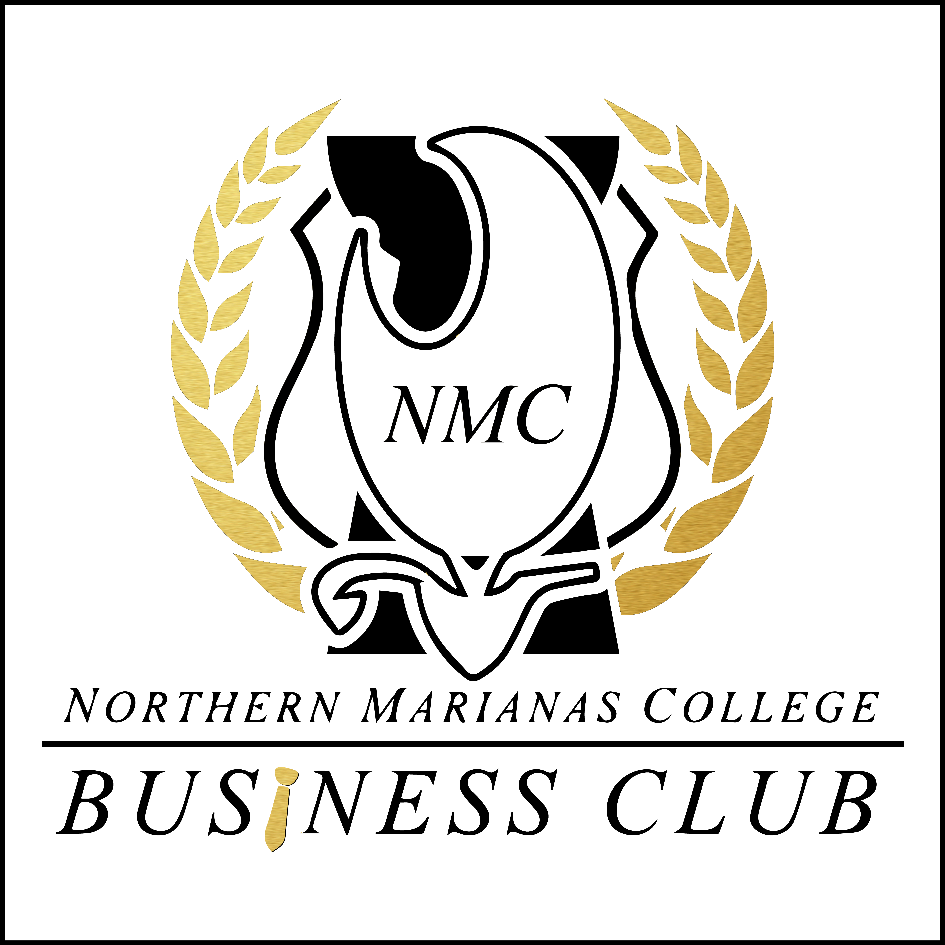
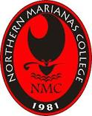

Northern Marianas College

The Business Club
P.O. Box 501250; Saipan, MP 96950

Membership Application

SEMESTER ENTERING: FALL 20____ SPRING 20____

(Select One (1) and indicate semester year)

DEGREE LEVEL: (Check one)
Freshman Sophomore Junior Senior

DEGREE PROGRAM: (Check one)
Bachelor of Science in Business Mgmt. Associates in Arts Business
AAS Business Administration Other (Specify) _________________

Full Legal Name: __________________________________________________________________________________
LAST FIRST MIDDLE

Mailing Address: __________________________________________________________________________________
Number/Street City State Zip Code

Contact Information: _______________________ _______________________ _________________________
Home Work Cell

E-mail address(s): 1.) ___________________________________ 2.)_________________________________________

Hobbies/Special Interest: ____________________________________________________________________________
_________________________________________________________________________________________________
CLUB MEMBERSHIP FEE
In addition to the application, there is a membership fee of $5.00 (five dollars) per Semester. Payments can be made with the Treasurer or with a Business Club Advisor.

By submitting this form, I understand that the NMC Business Club at the Northern Marianas College will not be liable for any claims or damages to person or property, either directly or/and indirectly, arising from my participation in activities and events hosted by or with the NMC Business Club.

______________________________________________ ________________________________
APPLICANT’S SIGNATURE DATE

(FOR OFFICE USE ONLY) 1 year-Membership
_________Semester
Member Honorary Invoice Reference #: _________

_____________________________________ ___________________________________
Signature of Club Representative Advisor

